### CHAPTER SEVEN

**Issue and Wear of the Uniform**

7-1. **SCOPE**. This chapter contains guidance on the proper wear of the uniform. The provisions of this policy apply to all cadets. This information is in addition to information in the Leadership I textbook, AFI 36-2903 and the AFJROTC Uniform and Awards Guide. (Uniform pictures are Attachments 1-9).

7-2. **UNIFORM GUIDANCE LETTERS.** Each cadet will be given the welcome letter, uniform policy letter and local guidance letters. These letters are to be read and signed by both cadet and parent and returned to ROTC by the date the SASI/ASI specify each school year. These letters will help the parent and cadet understand the requirements for wear of the military uniform and the signature pages will be filed in the cadet’s records each. These letters are completed each year to keep cadets and parents abreast of any changes in uniform policy.

7-3. **RIBBONS OF OTHER SERVICES**. Cadets are authorized to wear ribbons earned while enrolled in JROTC programs of the Army, Navy, Marine Corps, or Coast Guard. In addition, Civil Air Patrol ribbons (General Spaatz, Amelia Earhart, General Mitchell, and General Curry Awards only) may be worn. Other Services ribbons are grouped by service (in order of precedence) in the following order: Army, Navy, Marine Corps, and Coast Guard. Other services’ ribbons are worn below Air Force ribbons. Active duty insignia or badges are not authorized.

7-4. **MEDAL AND RIBBON WEAR**. **Medals and ribbons may be worn simultaneously for formal, semiformal, or special occasions of a limited nature**. The routine wear of medals and ribbons together is prohibited. Examples of appropriate occasions are the Military Ball, the Annual Awards Ceremony and the Pass-In-Review parade. The Squadron Commander may ask permission for personnel to wear medals and ribbons at other times -- the SASI/ASI is the approval authority.

7-5. **INSIGNIA**

a. **Cadet Rank**. The correct cadet rank (once received) is worn on the shirt (blouse), Service Dress Coat (if worn) and the windbreaker.

b. **Name tags.** The blue name tags will be worn on the light blue shirt only. The blue name tags are not worn on the windbreaker (lightweight jacket) or the Service Dress Coat**.** Silver metal name tags will be worn on the Service Coat.

c. **AFJROTC Shoulder Patch/School Patch**. The shoulder patches will be worn on the shirt (blouse), Service Dress Coat (if worn) and the windbreaker.

d. **Ribbons/Badges**. Once presented, cadet ribbons and badges are to be worn on the uniform at all times.

e. **Aiguillettes (Shoulder Cords)**. Aiguillettes distinguish leadership and staff positions and members of special groups, i.e., drill team. The shoulder cord is worn on the left shoulder and may be worn on the uniform at anytime.  **Only one shoulder cord can be worn at a time** (example: A Color Guard member who is also on the drill team will not wear the Color Guard cord while wearing the drill team cord). The SASI or ASI are the approval authority for shoulder cords.

7-6. **GENERAL INFORMATION**. The AFJROTC uniform is the same as that worn by Air Force active duty personnel. Only the insignia rank, and patches identify you as a cadet. The uniform is the distinctive dress of a proud and honorable profession. Cadets must be aware of their responsibility for maintaining the uniform in good condition and wearing it proudly and correctly at the times and places designated by the SASI/ASI. They must be aware of the regulations governing the wear of the military uniform.

a. **Uniform Day**. One day each week will be designated as “Uniform Day”. For MT-20161, normally Wednesday will be the Uniform Day. You must wear your uniform on the designated uniform day and you will receive a grade. If you are absent on the designated uniform day, you must make up that day the first day you return to class. Failure to wear your uniform on the designated day or make up an absence could play a significant role in whether you pass or fail your AFJROTC class. Your grade will be determined by how you appear, as well as, how you behave while in uniform. Keep in mind, however, if you are part of a specialized team (i.e. Drill Team, Color Guard), you may be required to wear your uniform more than one day per week.

b. **Uniform Issue**. Uniforms will be issued at the beginning of each school year, starting with returning cadets. New cadets will be issued once returning cadets have been issued their uniforms. Each cadet will be required to sign for each individual uniform item issued and will be accountable for each item until it is returned to JROTC. Your uniform is LOANED to you by the United States Air Force. You must take good care of it and be accountable for it at all times. All uniform items issued will be returned to JROTC at the end of the year when the cadet will either no longer be in JROTC. **The uniform must be “Dry Cleaned” before final turn in.**

1. c. **Care of the Uniform**. Each cadet is responsible for keeping the uniform neat and clean throughout the semester or year.

1. Shirts and blouses should be washed in cold water, using mild detergent and **NO** bleach. Coats, jackets, pants and hats must be professionally dry cleaned. Cadets are to monitor the condition of the uniform and when an item becomes unserviceable or too small, return it for replacement. However, if an item is lost, damaged or destroyed due to negligence, cadets will be liable for the cost of that uniform item. ***At the end of the year uniforms must be turned back in “Dry Cleaned***.”

* + 1. **Uniform Deposit**. A $20 uniform deposit will be charge prior to issue of uniforms. This deposit is charged to cover the cost of dry cleaning the issued uniforms if the cadet turns in their items not professionally dry cleaned. If cadet turns their issued uniforms in professionally dry cleaned, they will receive a refund of deposit or they can choose to forward deposit for the next school year.

2. The leather shoes issued by JROTC should be polished with regular black paste polish (KIWI brand is best) and lot of effort. Do not attempt to find an easy shine with paint on liquids, oil or grease because they will ruin the appearance of the shoe.

**Replacement Fee**. If uniform items are deemed unserviceable and condition of uniform item(s) are not due to regular wear and tear the cadet will be charged a replacement fee for the cost of the uniform item(s).

e. **Wear of the Uniform**.

1. You will not be allowed to wear the military uniform until you are taught how to properly wear the uniform IAW military regulations stated in paragraph 7-1. The cadet will wear only the items issued by JROTC when in uniform. Do not mix uniform items and civilian items together. When wearing the uniform, it is the cadet’s responsibility to ensure their personal appearance (hair, facial hair, jewelry, cosmetics, et.) and uniform meets military standards. Wear the uniform with pride insuring you meet the key elements of uniform wear; (1) Neatness, (2) Cleanliness, (3) Safety, and (4) the Military Image. Wear the uniform correctly at all times, whether in the JROTC building or elsewhere on campus, whether on campus or off campus, during lunch, in the cafeteria and while going to and from class.

2. Cadets are to wear the uniform the entire school day. There are some exceptions to this rule. Change and dress appropriately for Gym class and sports. Change or cover the uniform for any special classes where the uniform may get dirty or damaged. When in doubt, ask an instructor. In these situations, make sure you always have time to get back in the uniform before leaving that class.

3. When in uniform, the cadet must wear the hat whenever you are outside, no matter where you are. You may remove your hat while in a car or on a bus, but when you leave the vehicle your hat must be on your head. The hat must be worn when going to or from class and in class, if outside, and at lunch if outside or on the patio. The windbreaker, when worn, must be zipped up more than half way

f. **Prohibitions**. Do not wear the AFJROTC cadet uniform:

1. If it does not meet Air Force specifications.

2. If participating in public speeches, interviews, picket lines, marches or rallies, or any public demonstration when it may imply the Air force sanctions the activity.

3. While seeking private employment or other commercial interests.

4. While working at a civilian job.

5. While participating in civilian court proceedings.

6. With civilian attire.

7. While “hitchhiking”.

1. On occasions other than the designated uniform days without prior approval from the SASI/ASI. You should wear your uniform directly to school in the morning and directly home in the afternoon, unless approved by the SASI/ASI.

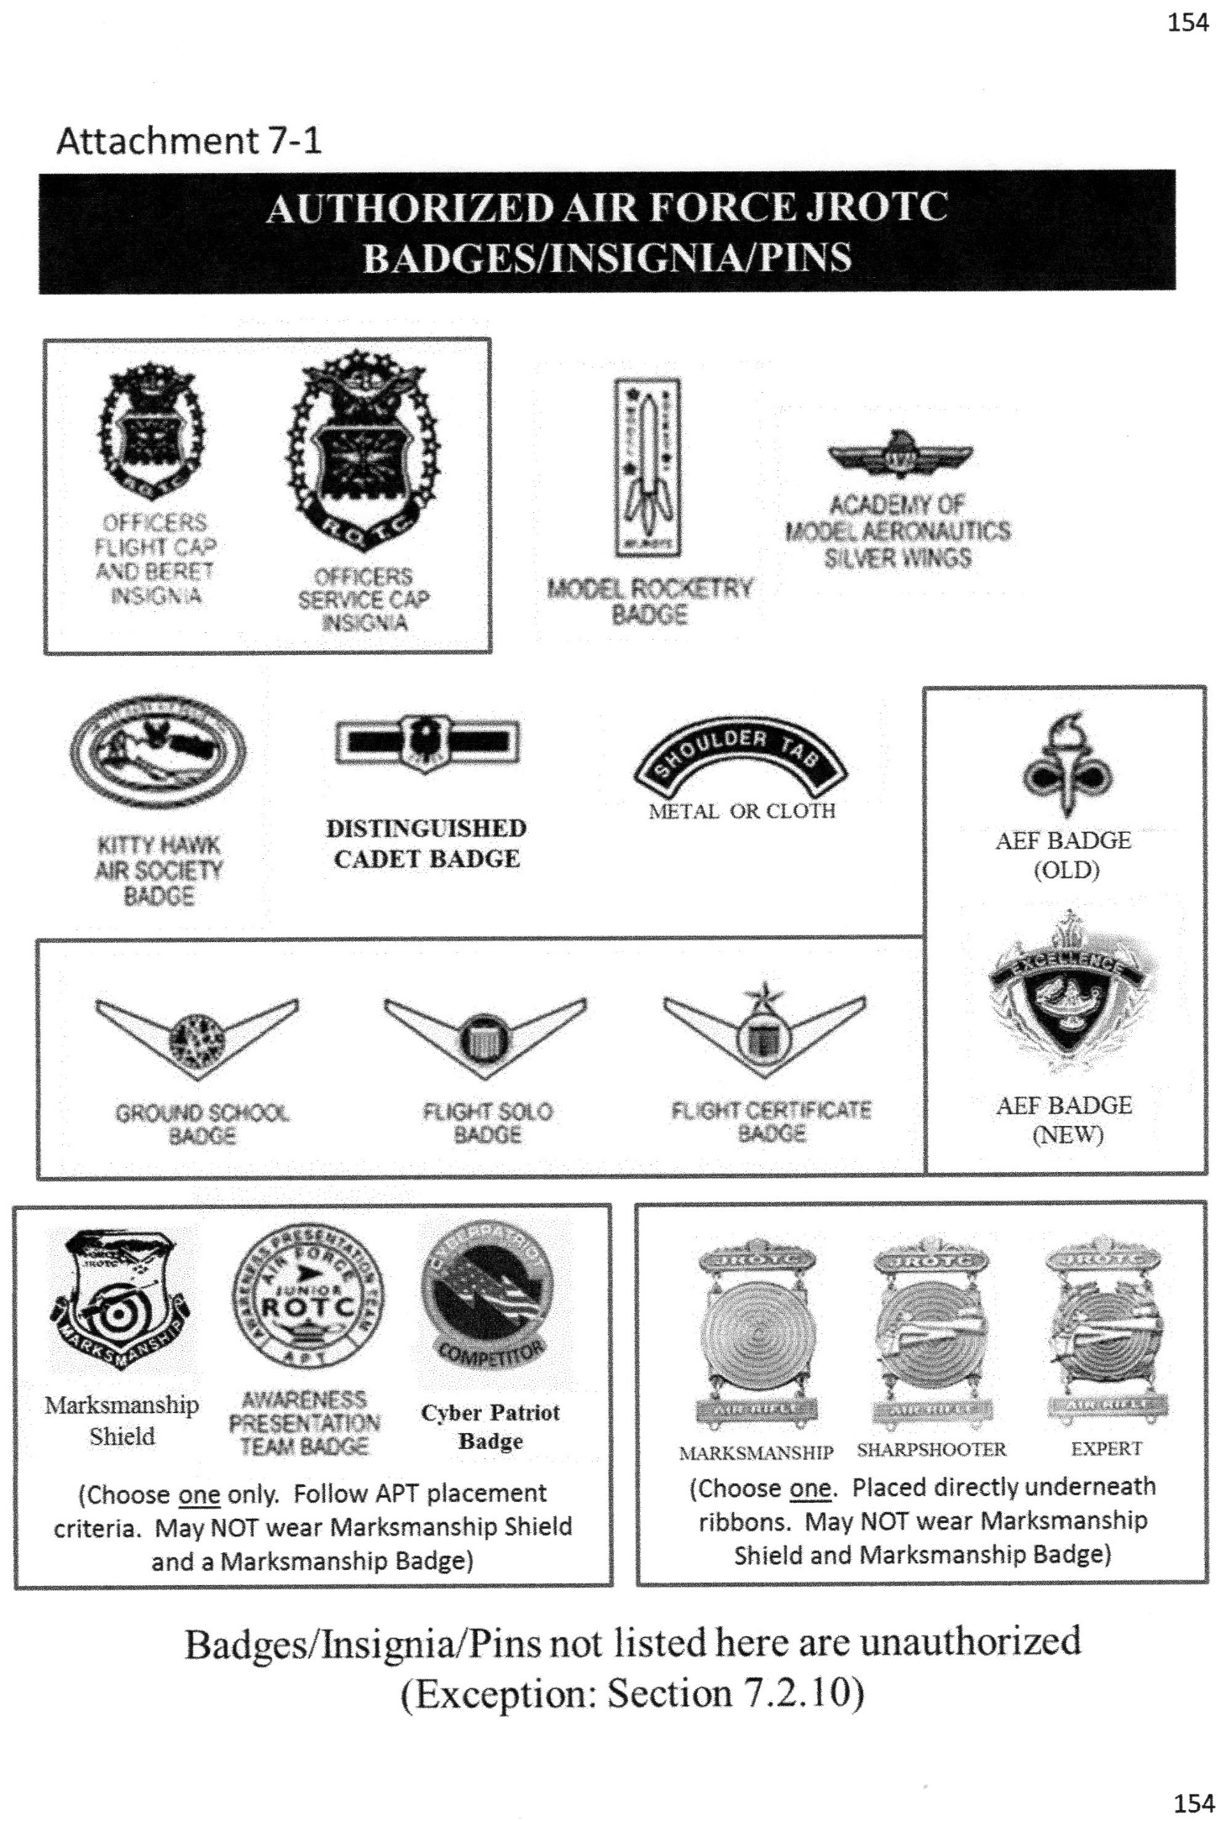MALEHG

ATTACHMENT 1

ATTACHMENT 2

ATTACHMENT 3

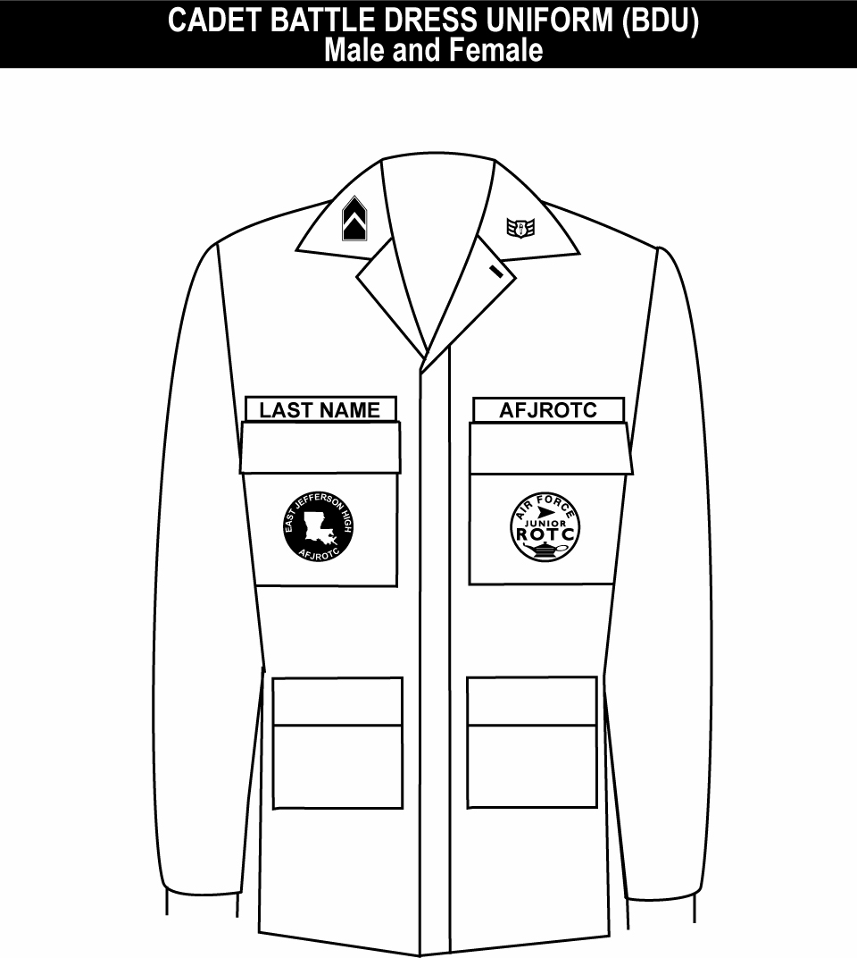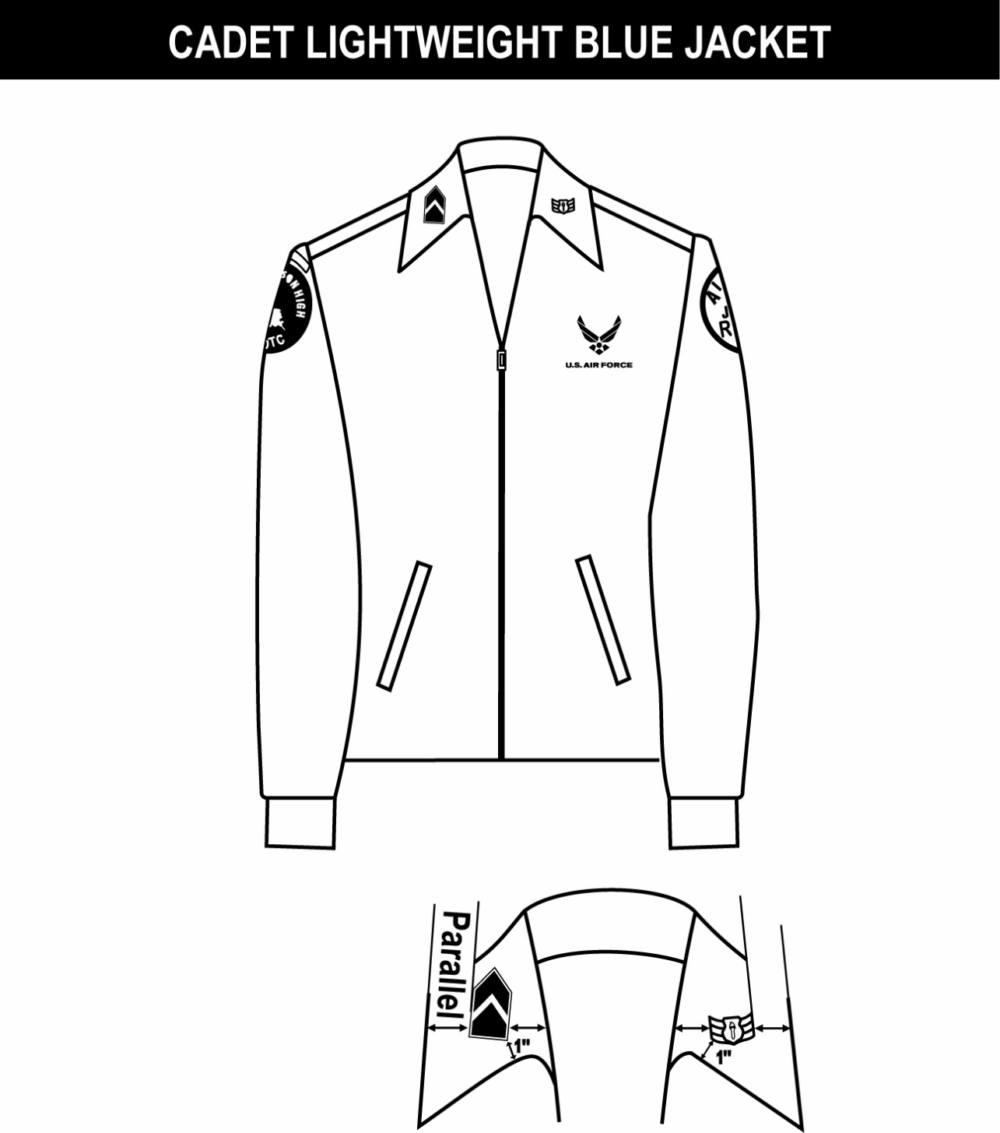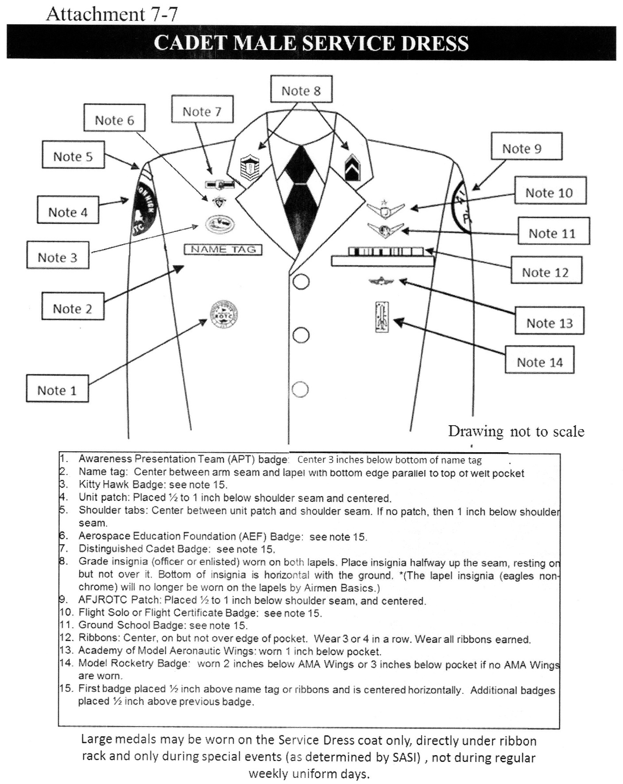

1. Unit patch worn on right pocket and centered.

2. Tapes grounded and centered on pockets.

3. Grade insignia (officer or enlisted) is worn on both left and right collars, centered on collar and parallel with bottom of collar. Airman Basic have no collar insignia.

4. AFJROTC patch worn on left pocket and centered.

Note 4

Note 1

Note 3

Note 2

ATTACHMENT 4

Outer edge

Inner edge

Inner edge

Outer edge

LIGHTWEIGHT BLUE JACKET

COLLAR INSIGNIA

Note 8

Note 7

Note 6

Note 5

Note 3

Note 2

Note 1

1. (Officers only) When placing rank on epaulet instead of collar, use standard size metal rank, center on epaulet 5/8 in from shoulder seam.

2. Shoulder tabs are centered between unit patch and shoulder seam. If no patch, then 1” below shoulder seam.

3. Unit patch on right sleeve ½ to 1 inch below shoulder seam and centered.

4. Grade insignia (officer and enlisted) is worn on both left and right collar. Airman Basic have no collar insignia.

5. Optional item: center vertically between the shoulder seam and where the underarm side seam joins the armhole sleeve and center horizontally between the center zipper and the sleeve armhole seam.

6. AFJROTC patch on left sleeve ½ to 1 inch below shoulder seam and centered.

7. Jacket will be closed to at least the halfway point.

8. Center insignia horizontally on collar. Place 1 inch from bottom of collar and parallel to the outer edge of the collar.

Note 4

ATTACHMENT 5

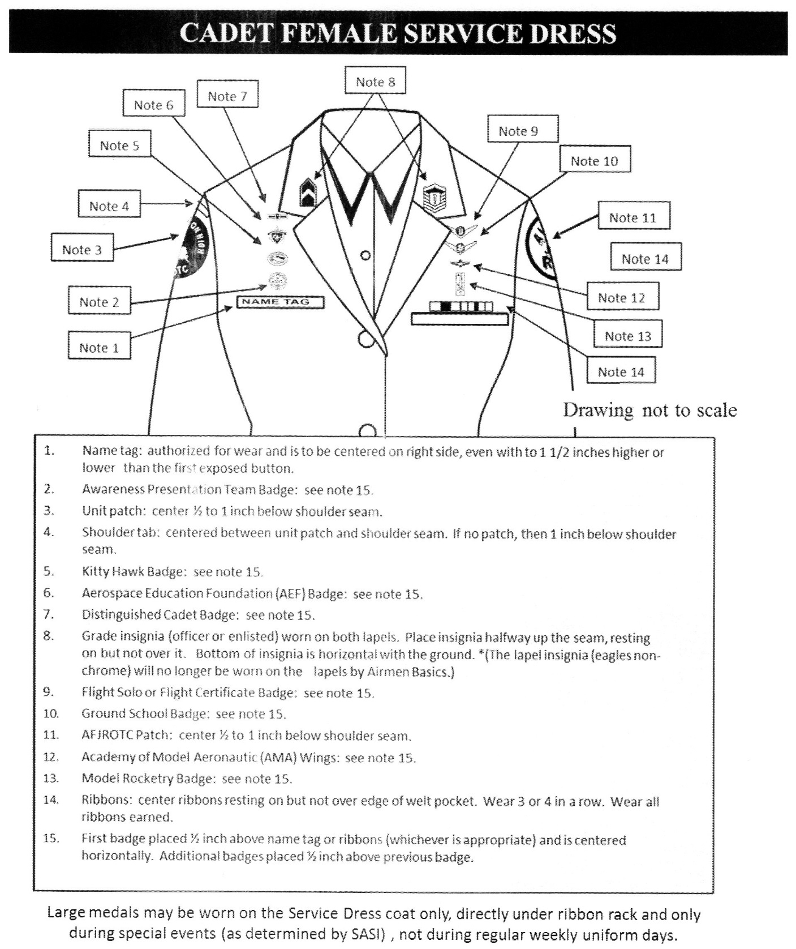

ATTACHMENT 6

ATTACHMENT 7

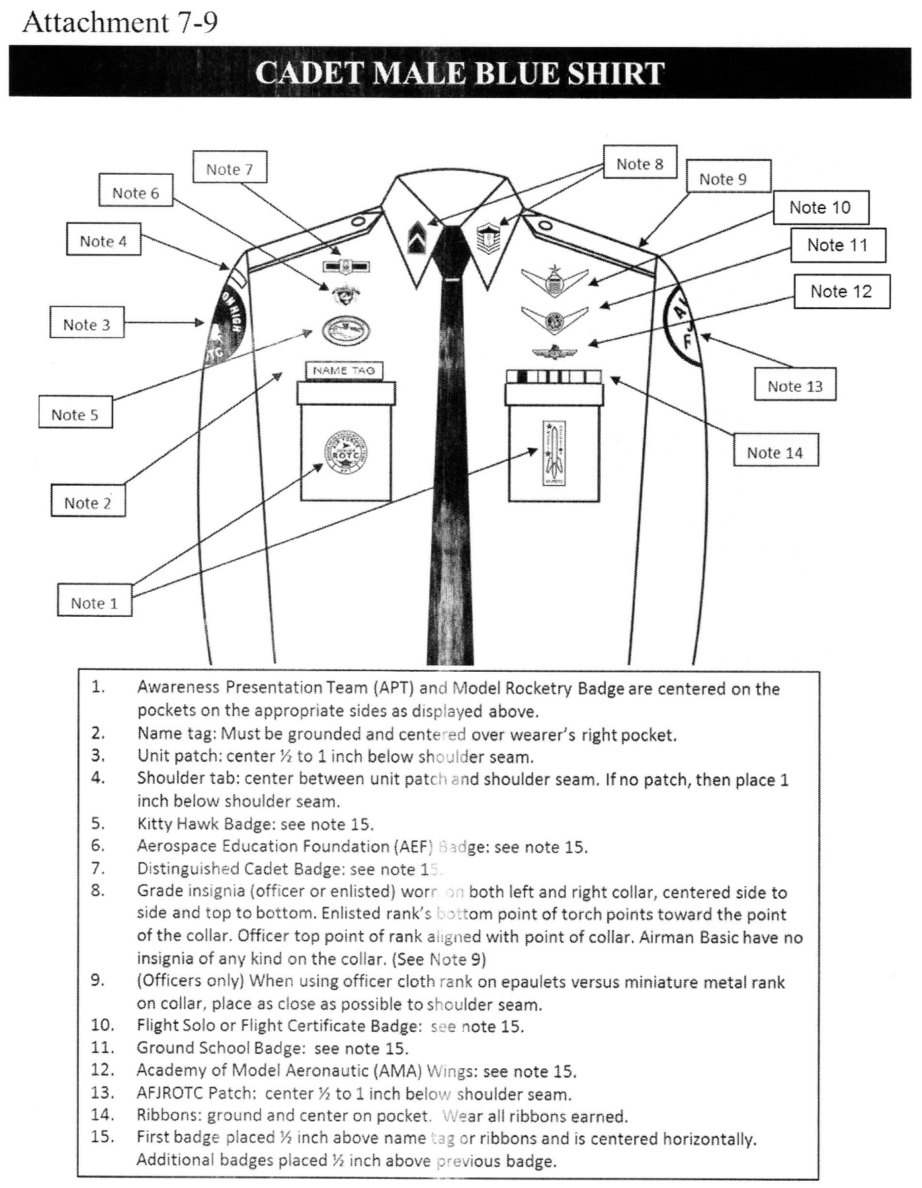

ATTACHMENT 8

